

11 Physics

Wave Properties

THE NATURE OF WAVES

Waves have the following characteristics.

1. They consist of disturbances progressing through all or part of a medium.
2. An energy change or source of energy is needed to set up the waves.
3. Energy is transferred as the wave progresses through the medium.
4. The medium itself is not moved from one point to another.

Example

On the ocean, a boat bobs up and down as the waves move underneath it. The boat does not move with the wave - energy is being transmitted but the medium does not move with it.

The water particles merely oscillate up and down about some equilibrium position in accordance to the energy as it reaches them.

Mechanical waves (e.g. water waves, sound) need a medium to travel in, while electromagnetic waves (e.g. light) do not need a medium.

MECHANICAL WAVES

This type of wave needs an energy source to produce a disturbance and an elastic medium to transmit the disturbance.

An elastic medium has particles that occupy a mean position from which they can be temporarily displaced by an outside force. They return to their original position after the force has ceased.

e.g. Air particles behave elastically.

There are two types of mechanical waves - longitudinal and transverse.

Longitudinal Wave (e.g. sound)

• The particles of the medium move parallel to the direction of propagation of the wave
disturbance.

• Longitudinal waves are a series of compressions and rarefactions.

• Compression - particles have been pushes closer together.

i.e. High pressure area.

• Rarefaction - particles are further apart.

i.e. Low pressure area.

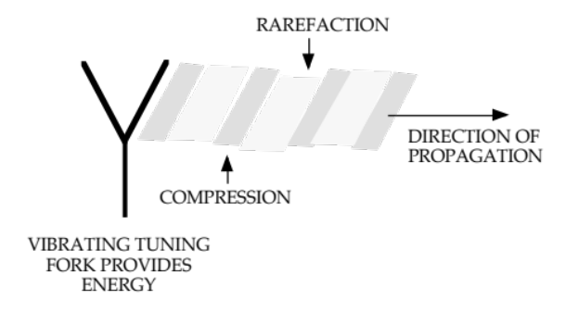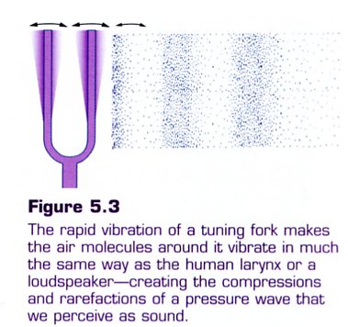

After the disturbance has passed a given point, the particles return to the equilibrium or mean position.

The distance a particle is displaced from its equilibrium position depends on the energy - the greater the energy, the greater the displacement.

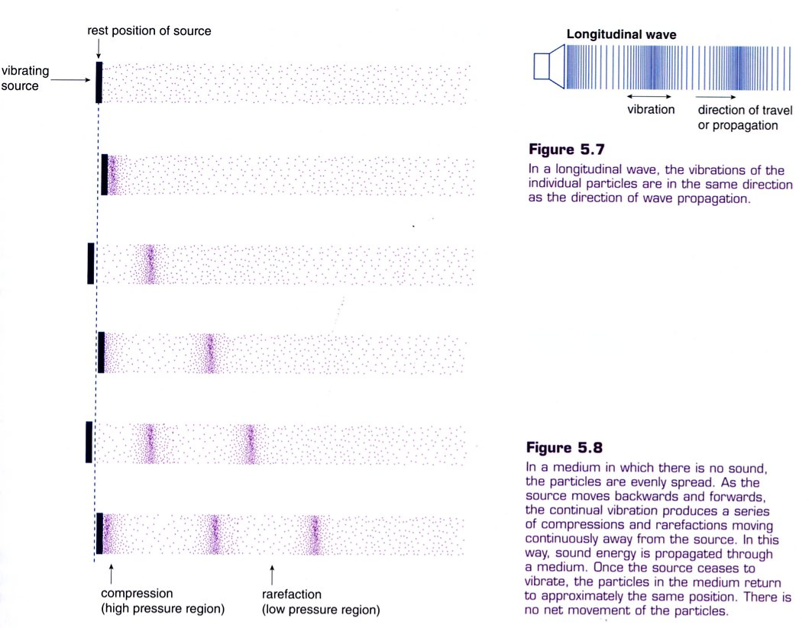
Transverse Waves (e.g. water waves)

• The particles of the medium move perpendicular to the direction of propagation of the
wave disturbance.

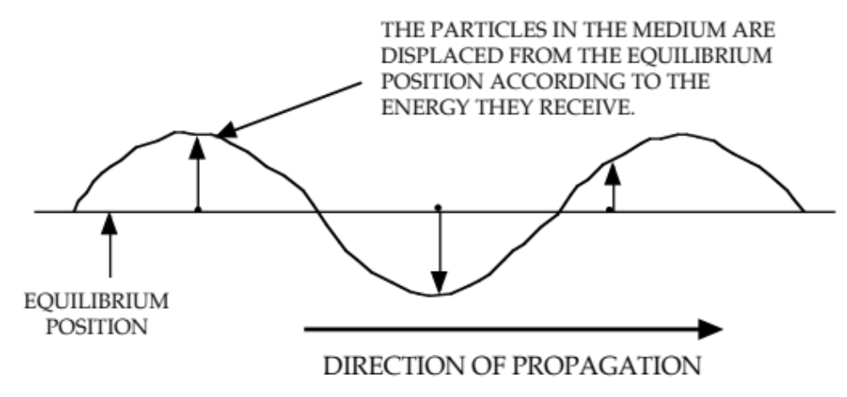

• The particles vibrate about their equilibrium position in a periodic fashion.

i.e. They move up and down only - they don’t move with the wave front as it moves
through the medium.

In both transverse and longitudinal waves, kinetic energy is transferred through the medium without the medium as a whole being displaced.

GRAPHING WAVE MOTION

There are two types of graphs that are drawn to represent a wave motion, namely displacement - distance and displacement - time graphs.

Displacement - Distance Graph

• This graph shows all of the particles of the medium at a given instant and their
respective displacement from the equilibrium position.

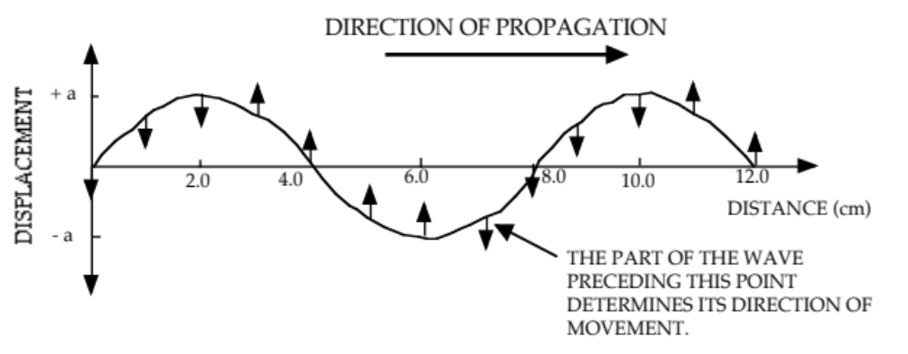

• The arrows on the diagram above show the direction each particle is moving at that
instant.

• The energy of the wave that is about to reach the point (i.e. the preceding part of the
graph) determines whether the movement will be up or down.

• Even though longitudinal waves cause the particles of the medium to move backwards
and forwards rather than up and down, this motion is still represented on a graph like
the one above.

Displacement - Time Graph

• This graph represents one point in the medium and shows how it is moving with
respect to time.

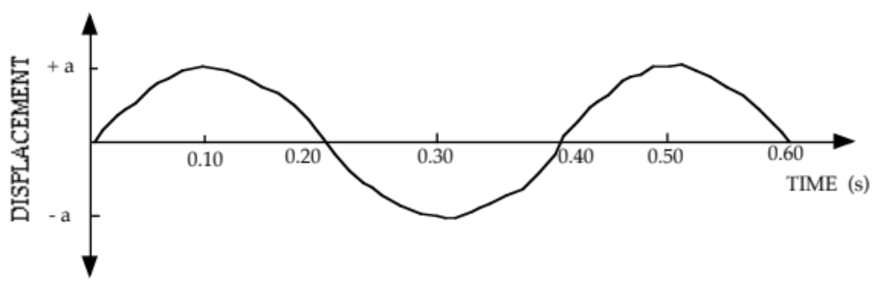
• This graph is used to represent both transverse and longitudinal wave movement.
CHARACTERISTICS OF WAVES

Phase
This is the position and motion of a particle at any instant.

Particles having the same displacement from their equilibrium position and moving in the
same direction are in phase.

Wavelength (λ)
This is the distance between two successive particles that are in phase.

Amplitude (a)
The maximum displacement of the particles from their equilibrium position.

Wave Speed (c)
The distance travelled by the wave per unit time.
i.e. It’s a velocity.

Frequency (f,ν)
The number of waves that pass a given point per unit time.

This is the same as the frequency of vibration of the energy source.

Period (T)
The time taken for one wavelength to pass a given point.

The time taken for a particle to undergo one complete oscillation.

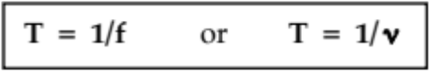

where f, ν = frequency (Hz)
T = period (s)

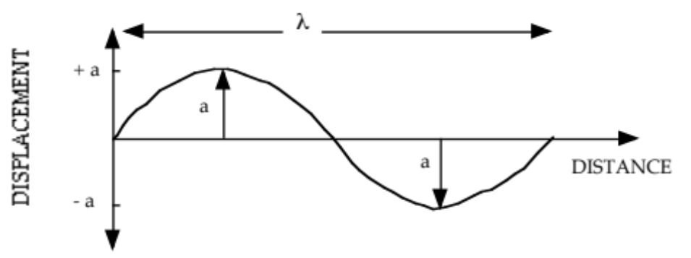

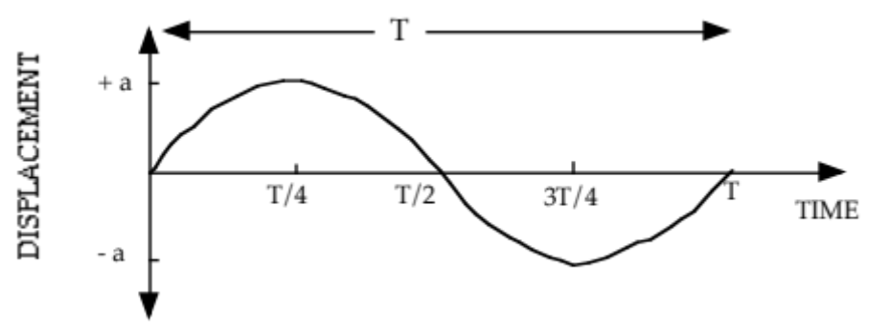

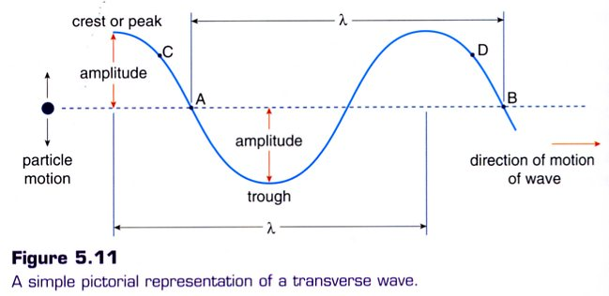

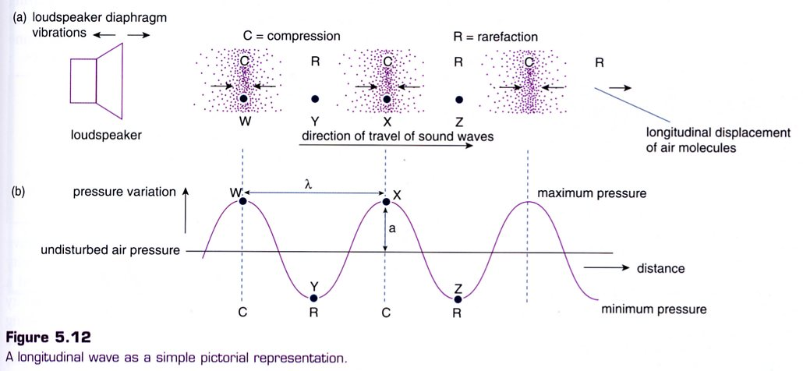
WAVE EQUATION

The velocity of a wave is given by:

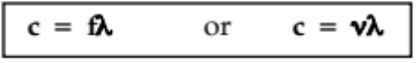

where c = velocity of the wave (ms⁻¹)
f, ν = frequency of the wave (Hz)
λ = wavelength of the wave (m)

This equation applies to both mechanical and electromagnetic waves.

Examples

1. A stone is dropped into a still pool of water. It generates 20 waves that cover a distance of
10.0 m of the surface. The outer wave covers the 10.0 m in a time of 5.00 s and the average
height of the waves is 10.0 mm (crest to trough).

(a) Determine the wavelength and velocity of the waves.
(b) Calculate the period of the waves.
(c) Draw a displacement - time graph to represent the motion of the waves.

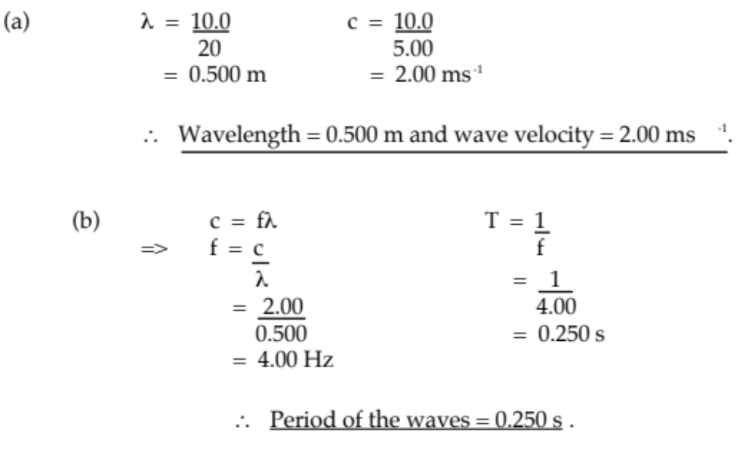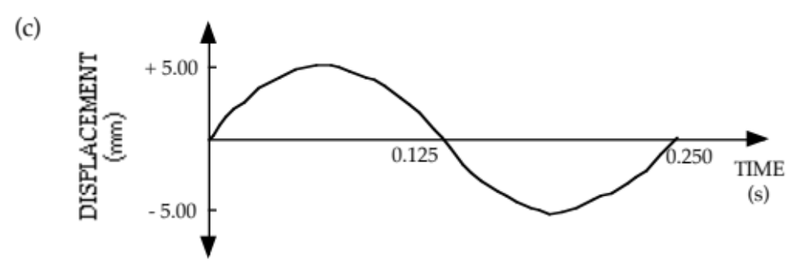

2. Radio station JJJ operates at 99.3 MHz. What is the wavelength of the transmission?

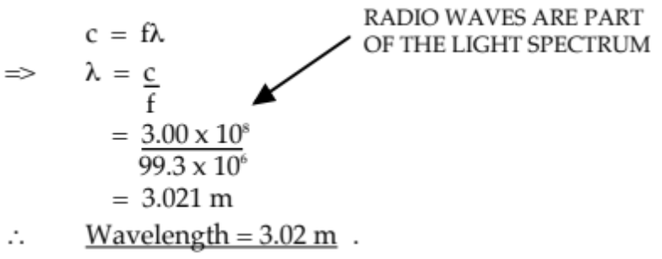

3.

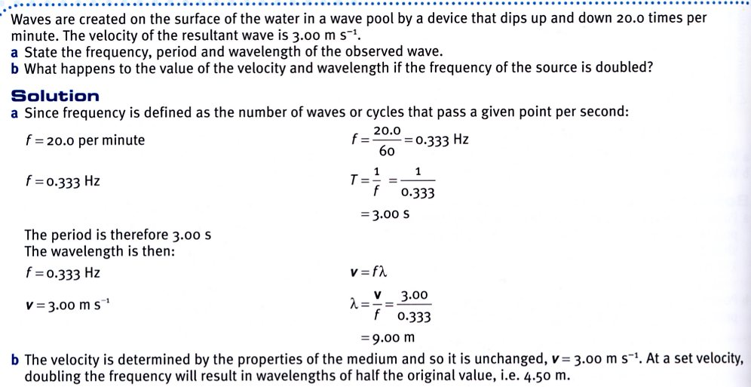

REFLECTION

Waves are reflected by barriers, the amount of energy reflected being determined by the energy-absorbing nature of the barrier.

Reflecting surfaces can be classified as follows.

Rigid

• Absorbs little or no energy - all is reflected.

e.g. Walls of a pool are rigid to any water waves.
String fixed at one end.

• The reflected wave is 180° out of phase to the incident wave.

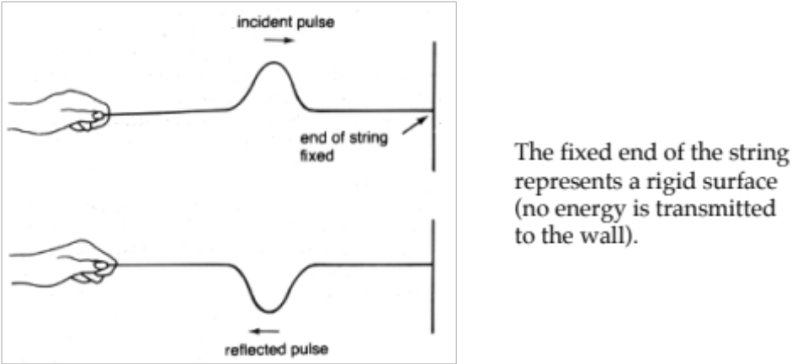

Non-Rigid
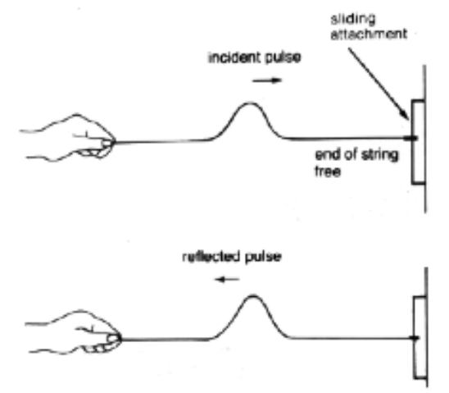
• Some energy is absorbed, the rest is reflected.

• The energy of the reflected wave is less than the
energy of the incident wave.

• The reflected wave is in phase with the incident
wave.

e.g. Carpet absorbs much of the incident sound
energy, resulting in a lower level
of reflected sound in a room.

• A string attached at a “free end” can represent a
non-rigid surface.

Laws Of Reflection

1. The angle of incidence (i) = The angle of reflection (r)

2. The incident ray and reflected ray are on opposite sides of the normal, and all three are
in the same plane.

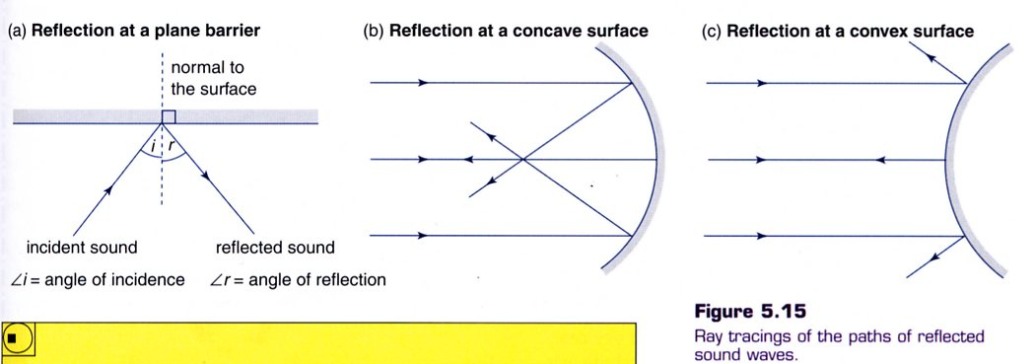

REFRACTION

Refraction occurs when there is a change in the velocity of a wave as it travels obliquely from one medium into another.

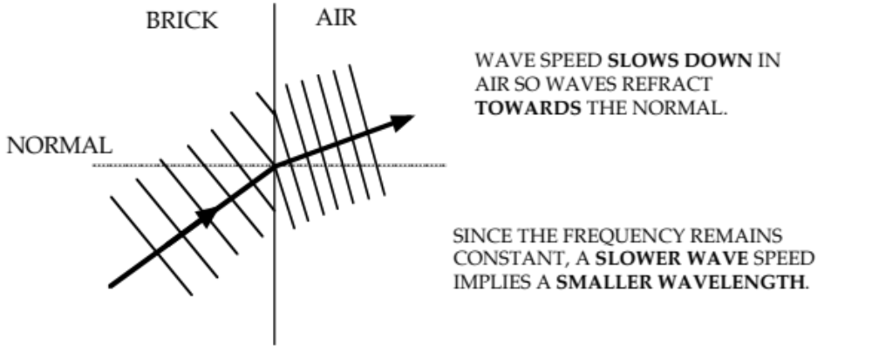

Slower speed in second medium => smaller λ, refract towards normal.

Faster speed in second medium => larger λ, refract away from normal.

If the incoming wave is perpendicular to the boundary of the two media, no refraction occurs.

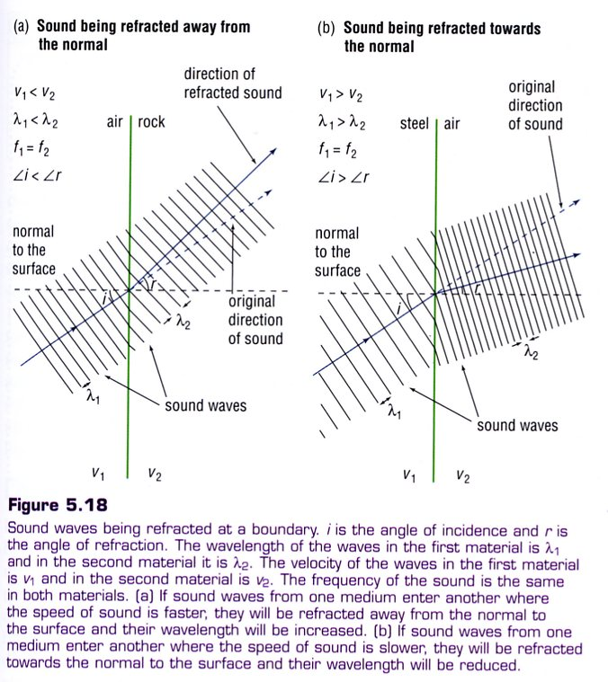
Examples

1. Waves in the ocean slow down in shallow water and refract towards a normal to the beach,
meaning that the waves arrive nearly parallel to the beach.

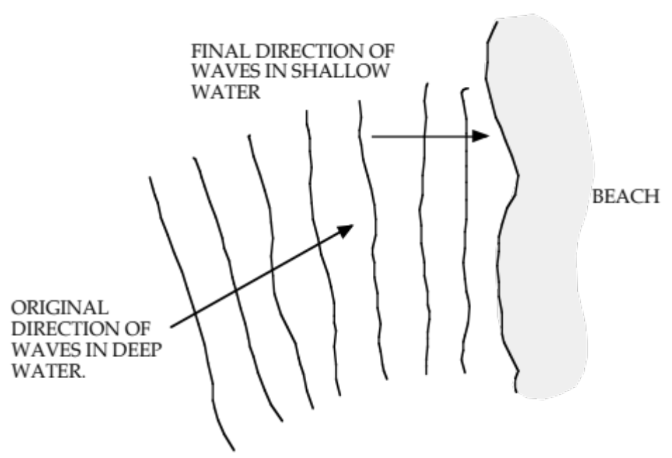

2. Sound is refracted by layers of air of differing densities, though the boundaries are ill-defined.
When cooler air is trapped near the ground at night, sound can be reflected back down to the
ground.

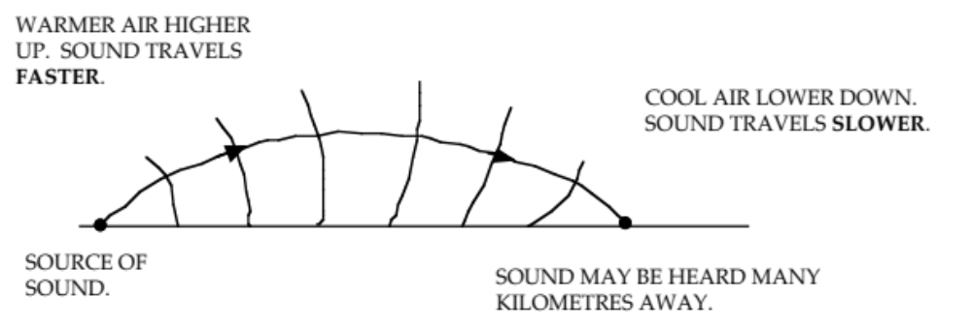

DIFFRACTION

Diffraction may be defined as the spreading out and change in direction of part of a wave as it passes around an obstacle or through an aperture in an obstacle.

It is at a maximum when the obstacle or aperture is about the same size as the wavelength of the incident wave.

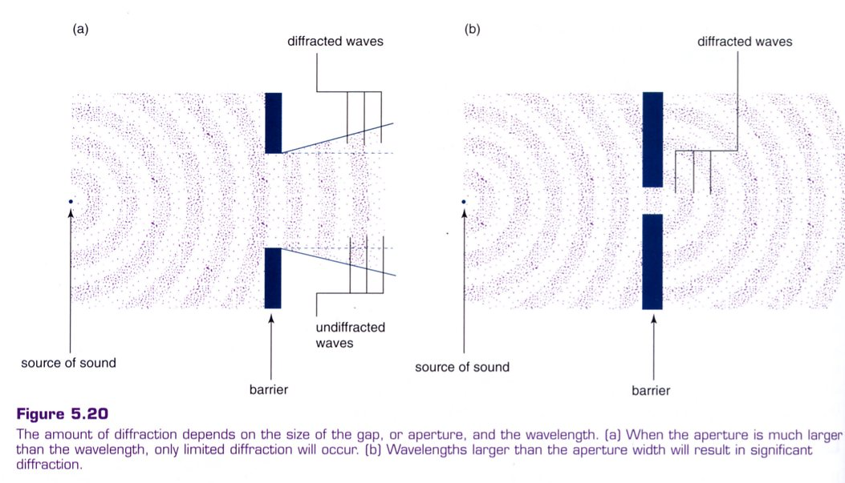

Examples

1. Sounds made outside a door can quite clearly be heard inside a room. The wavelengths of the
sound waves are about the same size as the 1.00 m width of a standard door so the waves
diffract into the room.

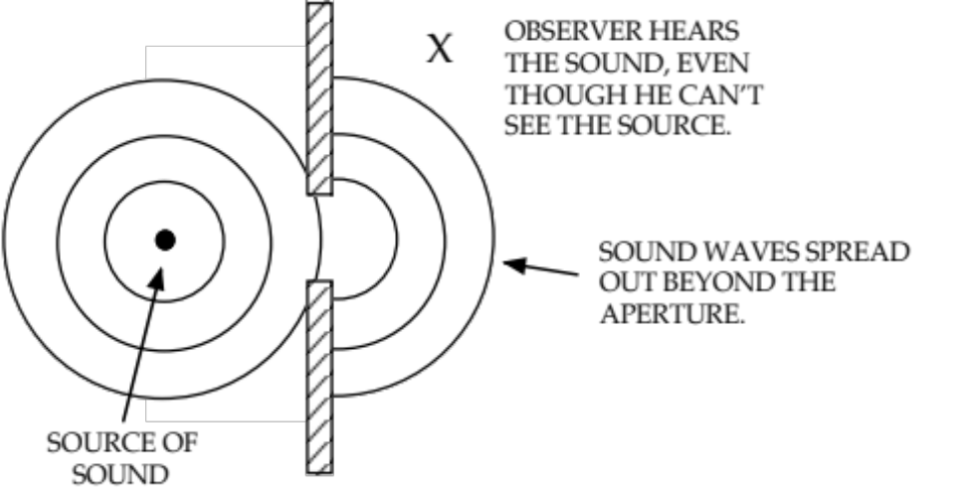

Reflection of sound from the walls will also help the sound reach the observer.

2. Ships and lighthouses have very low pitch horns so that they are heard clearly. Low sounds
have wavelengths of several metres which is typical of distances between objects in a
harbour.

3. Visible light waves have wavelengths of 4000 - 7000 Å (4.0 x 10⁻⁷ - 7.0 x 10⁻⁷ m). This
distance is achieved on a diffraction grating, consisting of 600 -1000 lines per millimetre
ruled on a piece of glass or plastic. The distance between the lines corresponds to the
wavelength of the incident light and diffraction occurs.

4. The wavelength of common sounds means that such sounds can bend around the
corner of common objects that are quite large.

e.g. Sounds can be heard around the corners of buildings.

5.
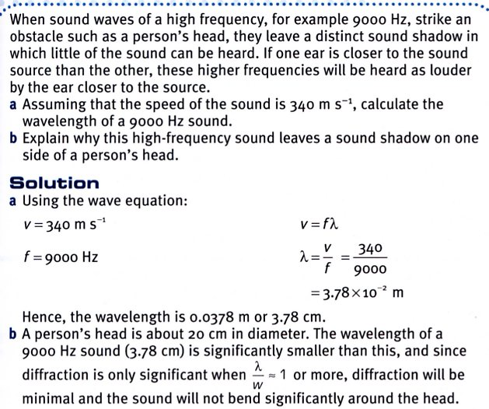
INTERACTIONS OF WAVES

Principle Of Superposition

When two or more waves travelling through the same medium at the same time meet, their
displacements combine.

Waves can interfere constructively or destructively.

Constructive Interference: two pulses combine to give a pulse of greater amplitude.

(a) Two pulses that are in phase to one another move in opposite directions in the same
medium (a string).
(b) When they meet, the resultant is the sum of both amplitudes.
(c) The pulses continue unaffected.

Destructive Interference: two pulses combine to produce a pulse with a smaller amplitude than
either of the two original amplitudes.

(a) Two pulses 180° out of phase to each other are moving in the same medium.
(b) Both pulses cancel to give a zero resultant.
(c) The pulses continue unaffected.
Stationary Waves

These are produced when two identical waves of equal amplitude, wavelength and speed travel in opposite directions in the same medium.

The resulting wave has points of zero displacement (called nodes) and maximum displacement (called antinodes) occurring in the same position.

i.e. The wave is not “travelling” but “stationary”.

Example

Plucking a string on a guitar (or any string instrument) will send a pulse down it to a fixed end. Here it reflects 180° out of phase and moves back down the string to the opposite end (which is also fixed).

A stationary (or standing wave) is produced with its nodes and antinodes appearing not to move.

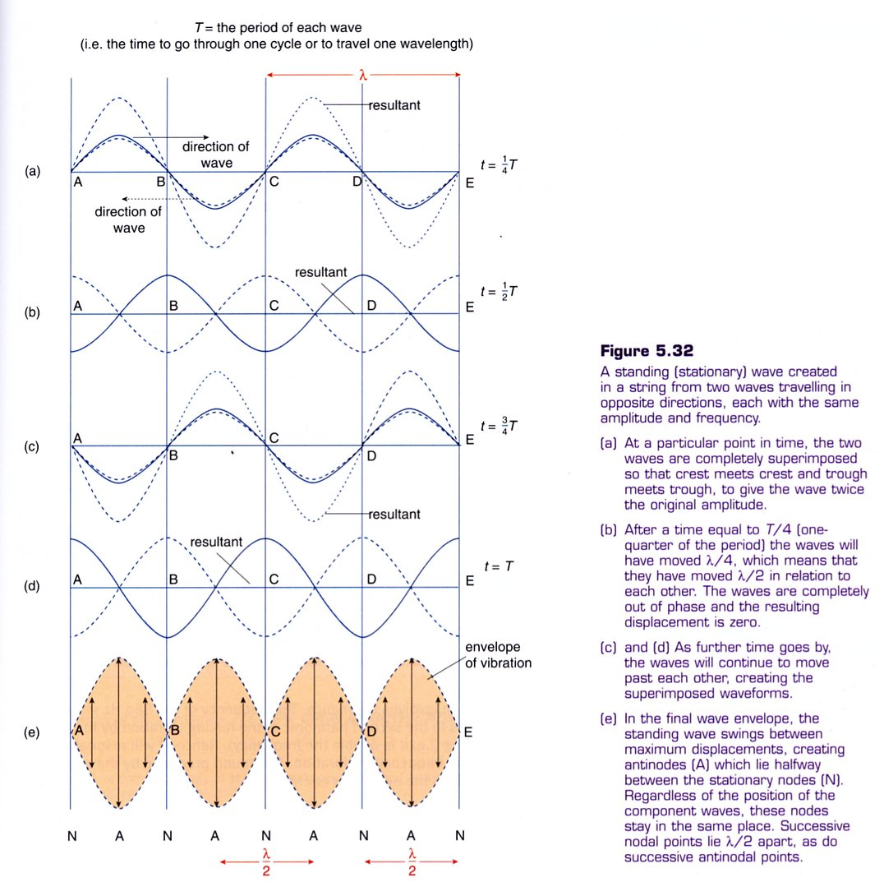
Interference From Two Point Sources

Consider two loudspeakers emitting the same sound (in phase) from two different points.

Points of maximum reinforcement (antinodes) and total annulment (nodes) will occur as shown in the diagram below.

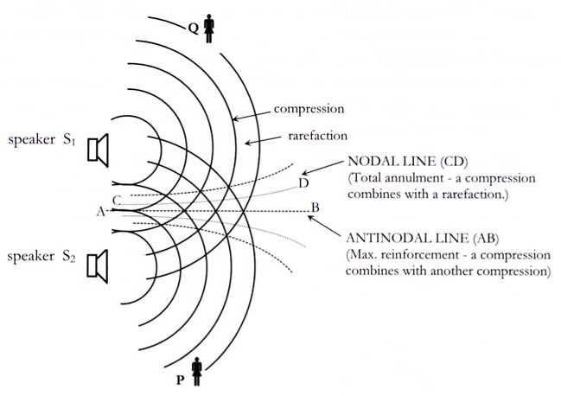
The distance between a nodal and antinodal line =
.

A similar interference effect (nodes and antinodes) will occur when two loudspeakers are facing each other and emitting the same sound in phase. A standing wave pattern forms between the speakers.

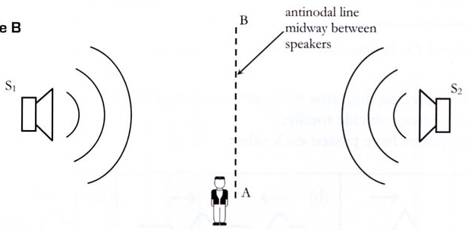

• Antinodal lines occur where there is constructive interference - a loud sound is heard.

• Nodal lines occur where there is destructive interference - a soft sound is heard.

The difference in distance from either speaker is called the path difference. There are two relationships to describe when constructive and destructive interference occur.

Constructive Interference: 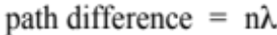

where n = 0, 1, 2, 3, ...

Destructive Interference: 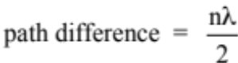

where n = 1, 2, 3, ...

Examples
8.00 m
6.00 m
x
patron

1. In a cinema, a patron is sitting in front of two
large speakers as shown. Assume the speakers
are in phase with each other.

(a) Calculate the path difference of the sound heard by the patron.

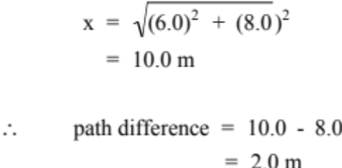

(b) If the speakers are both producing 680 Hz, what does the patron hear?

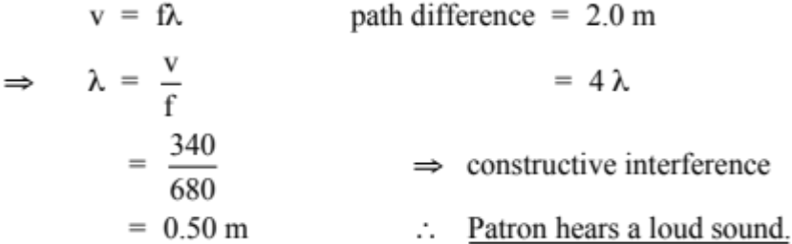

(c) What is the lowest frequency needed for a soft sound?

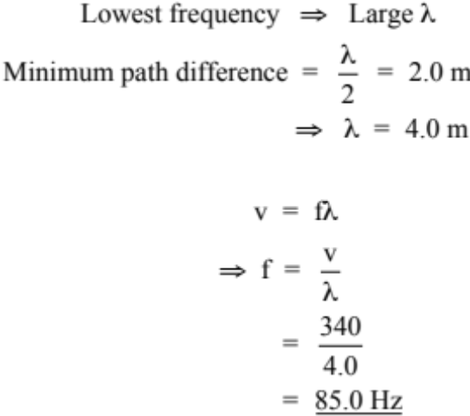

2.
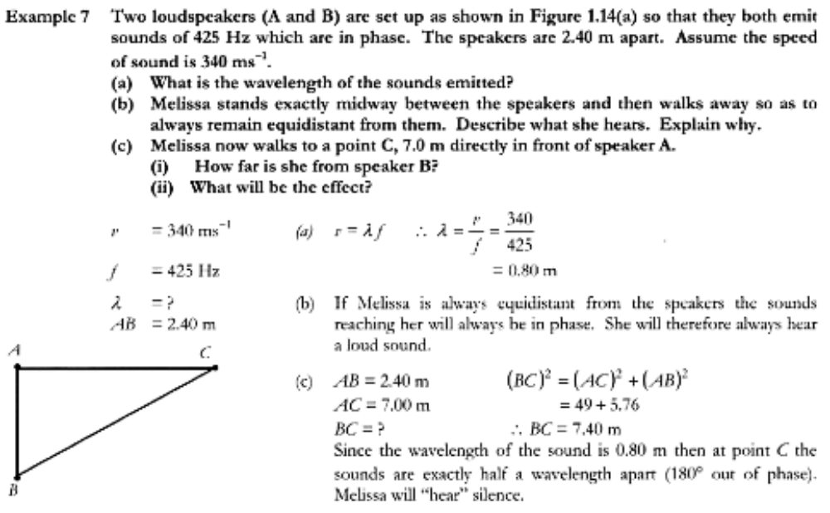
PRODUCTION OF SOUND

A sound wave can be generated by a vibrating object imparting a longitudinal wave motion to the surrounding medium.

The particles of the medium receive energy from the vibrating source and begin to vibrate at the same frequency.

The two fundamental requirements for the production and propagation of sound are a vibrating source and an elastic medium.

Example

A loudspeaker.

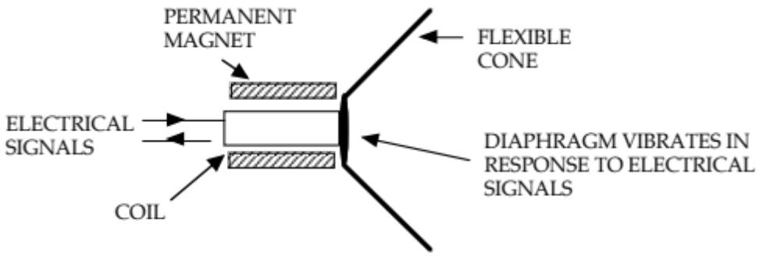

The coil moves in response to electrical signals as per the motor principle - its magnetic field
interacts with the permanent magnet’s field.

The diaphragm is connected to the coil and moves accordingly.

Sound is produced by the diaphragm vibrating, causing the cone to push against the air
particles and transfer energy to them.

As the cone moves forwards, a compression is produced. As it moves backwards, a
rarefaction is produced.

SPEED OF SOUND

The velocity of sound in a medium is determined by the elasticity and density of a medium.

The greater the elasticity, the greater the velocity.

The greater the density, the slower the velocity.

The velocity of sound in air is affected by temperature but not pressure.

i.e. Increasing temperature increases the velocity.

FREQUENCY AND PITCH

Increasing the frequency increases the pitch of the sound.

The pitch of a sound is the perception a listener has of a sound - whether it is high or low.

The human ear has a frequency range of 20 - 20,000 Hz.

Frequencies above 20,000 Hz are called ultrasonic. Dogs hear up to 50,000 Hz while bats respond up to 100,000 Hz.

Those less than 20 Hz are called infrasonic. These frequencies are generated by earthquakes and heavy machinery vibrating.

CHARACTERISTICS OF SOUND WAVES

Sounds can be classified as either musical notes or noise.

Musical Notes: vibrating body produces a regular frequency and a definite pitch.

Noise: produced by a body that does not vibrate with a regular frequency.

Stretched strings and columns of air vibrate in particular ways to produce sound.

Vibrations In Stretched Strings

As seen before, a standing wave is set up in a string that is attached at both its ends.

A string will vibrate in different ways according to how it is plucked, strummed, struck or where a bow is pulled across it.

i.e. In the middle, down towards one end, etc.

The lowest frequency at which a string will vibrate is called the fundamental frequency (or 1st
harmonic).

The next mode of vibration is called the second harmonic and has a frequency that is twice that of the fundamental frequency.

Subsequent harmonics have frequencies that are whole number multiples of the fundamental frequency.

Harmonic: A whole number multiple of the fundamental frequency.

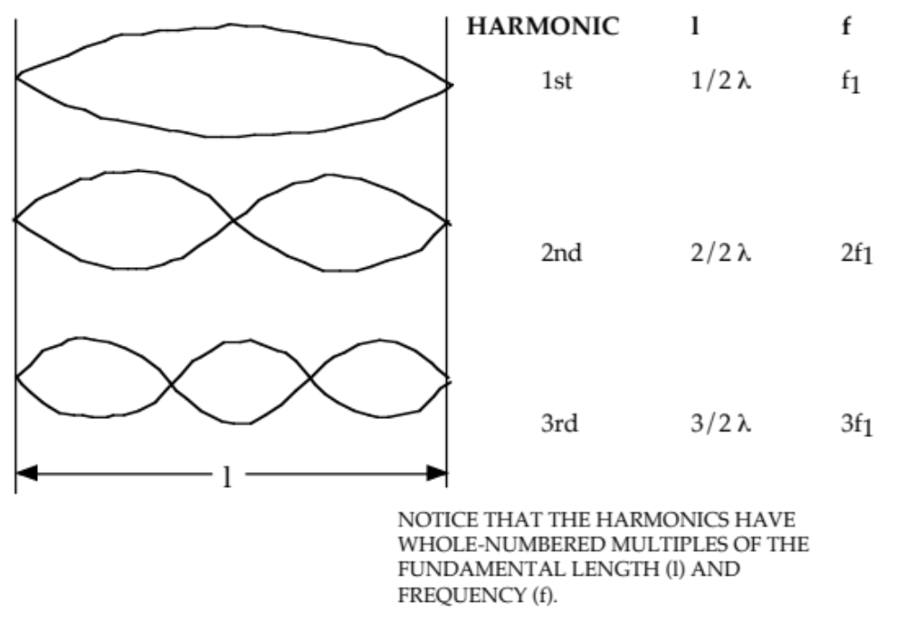

In strings, all of the harmonics are possible.

i.e. n = 1, 2, 3, 4, .....

The frequency of the harmonics in a string is given by:

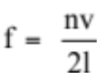

where f = frequency of vibration (Hz).
n = number of the harmonic.
v = speed of sound (ms⁻¹).
l = length of the string (m).

Examples

1.
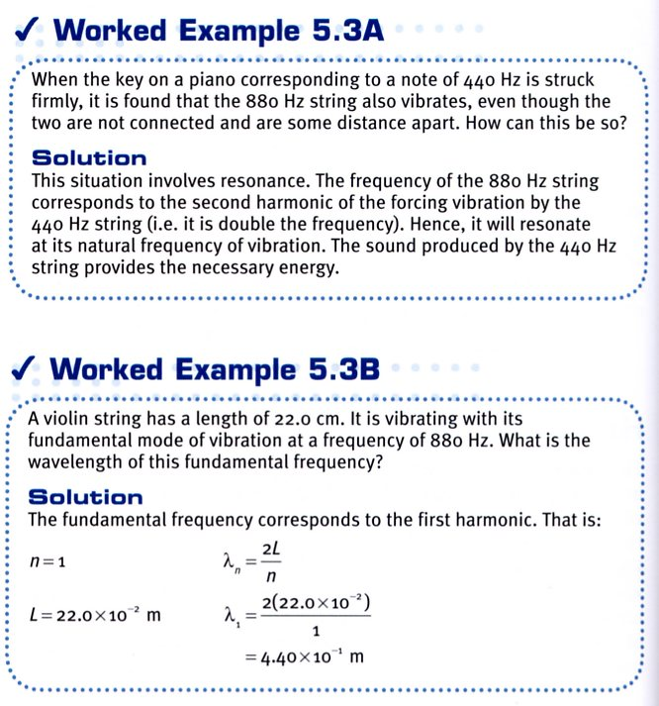

2.

Air Columns

The air in an open or closed pipe will resonate to a vibrating source placed at one end.

e.g. A tuning fork, blowing across the top of the pipe (the turbulence causes the vibrations),
a vibrating reed in a clarinet.

A longitudinal standing wave is set up in the pipe with reflection occurring from each end, regardless of whether it is the open or closed end.

At an open end, only an antinode is possible, and at a closed end only a node is possible.

Open Pipes
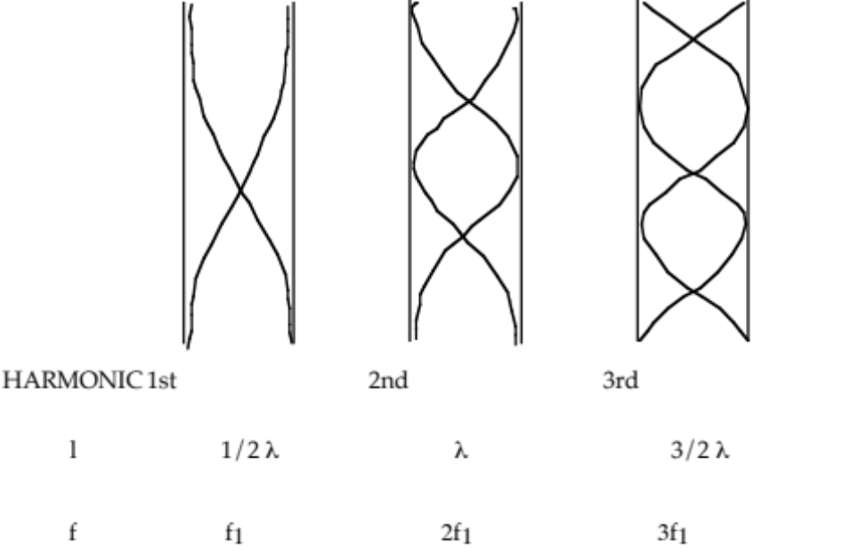

For open pipes, all harmonics are possible.

The fundamental length of the pipe is l = 1/2 λ .

The distance between successive harmonic lengths is 1/2 λ.
The frequency of the harmonics in an open pipe is given by:

where f = frequency of vibration (Hz).
n = number of the harmonic.
v = speed of sound (ms⁻¹).
l = length of the open pipe (m).

Examples

1. An open pipe has an effective length of 1.23 m. If the speed of sound in air is 3.40 x 10² ms⁻¹,
calculate:

(a) the fundamental frequency.
(b) the frequency and wavelength of the third harmonic.

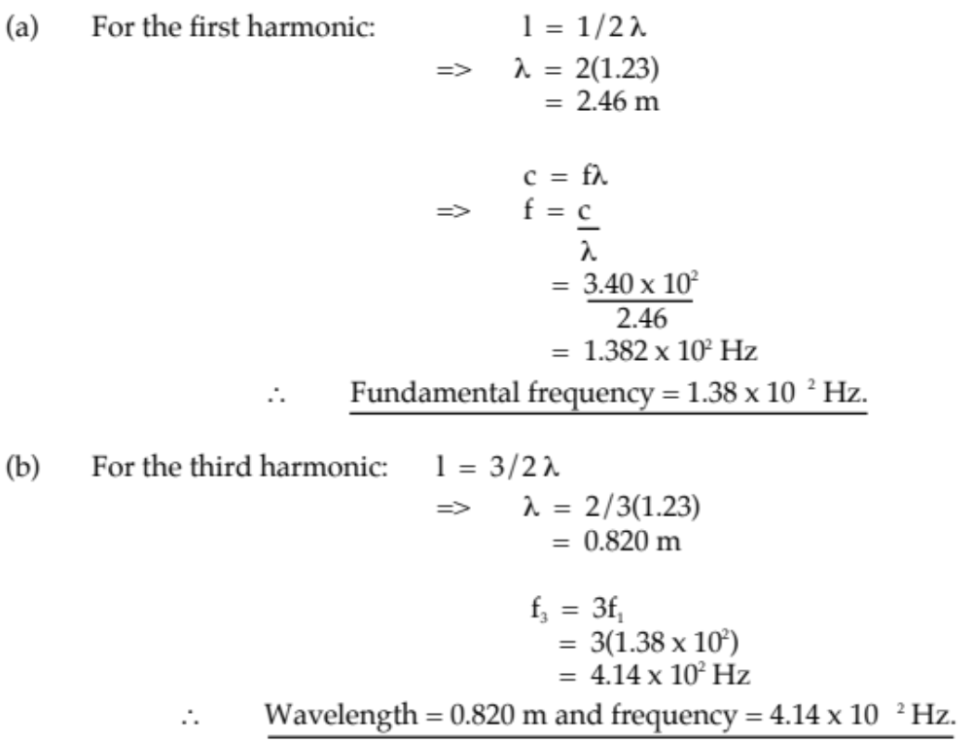

2.
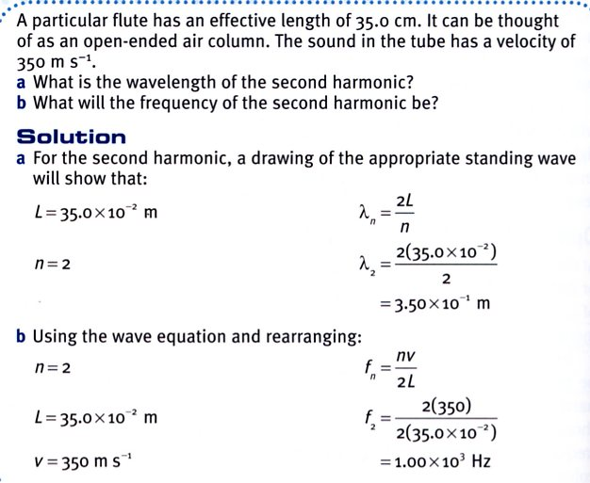
Closed Pipes

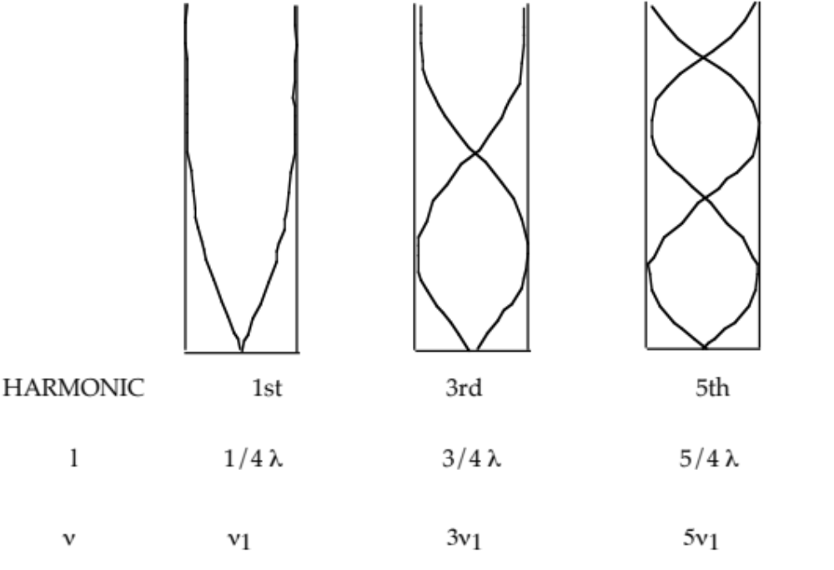

For closed pipes, only odd harmonics occur.

The fundamental length is l = 1/4 λ.

The distance between successive harmonic lengths is 1/2 λ.

The frequency of the harmonics in a closed pipe is given by:

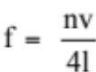

Examples

1.
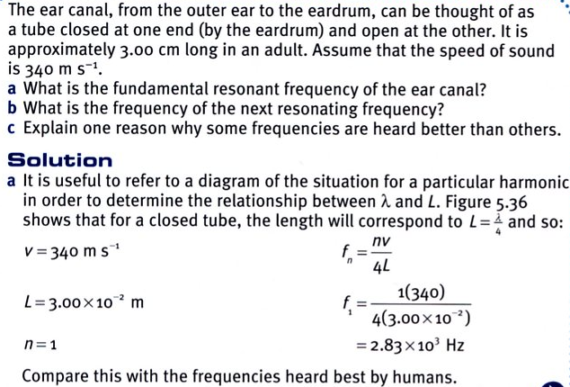

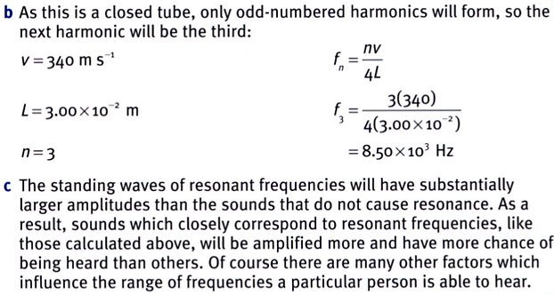

2. A group of students performed an experiment in the laboratory to determine the velocity of
sound in air. They filled a burette with water and sounded a 512 Hz tuning fork over the top
of it as they let the water slowly flow out the bottom. They found two successive resonant
positions when the air column was 0.170 m and 0.505 m from the top.

Using this information, calculate the value for the speed of sound the students obtained.

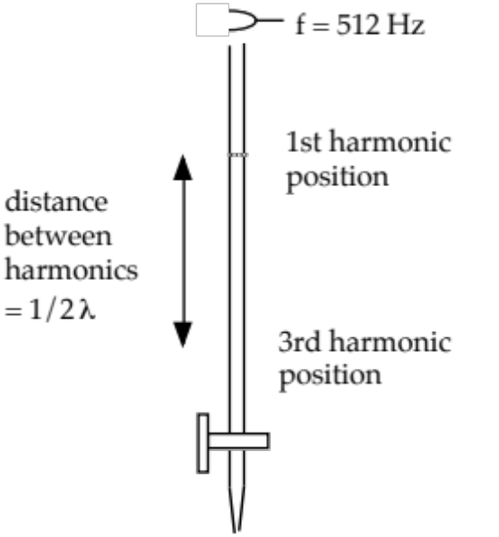
The first position is not used for calculating
the speed of sound since there is an “end
effect” that has to be taken into account. This
is due to the particles near the open end being
able to move in all directions rather than one
dimension.

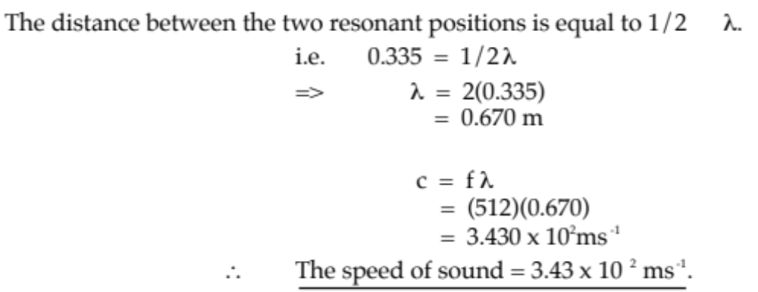

MUSICAL SOUNDS

Musical sounds have three distinct characteristics - pitch, loudness and quality.

When a piano and a flute play the same note having the same pitch and loudness, there is a clear difference between the sound produced by each instrument. There is a difference in the quality of the sounds.

The quality of a musical note depends on the number, nature and relative intensities of the harmonics present in the note.

The greater the number of harmonics present in a note, the better its quality.

Harmonics depend on the mode of vibration of a stretched string or an air column.

e.g. Consider a stretched string.

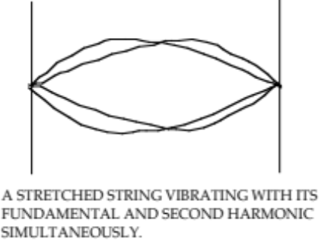
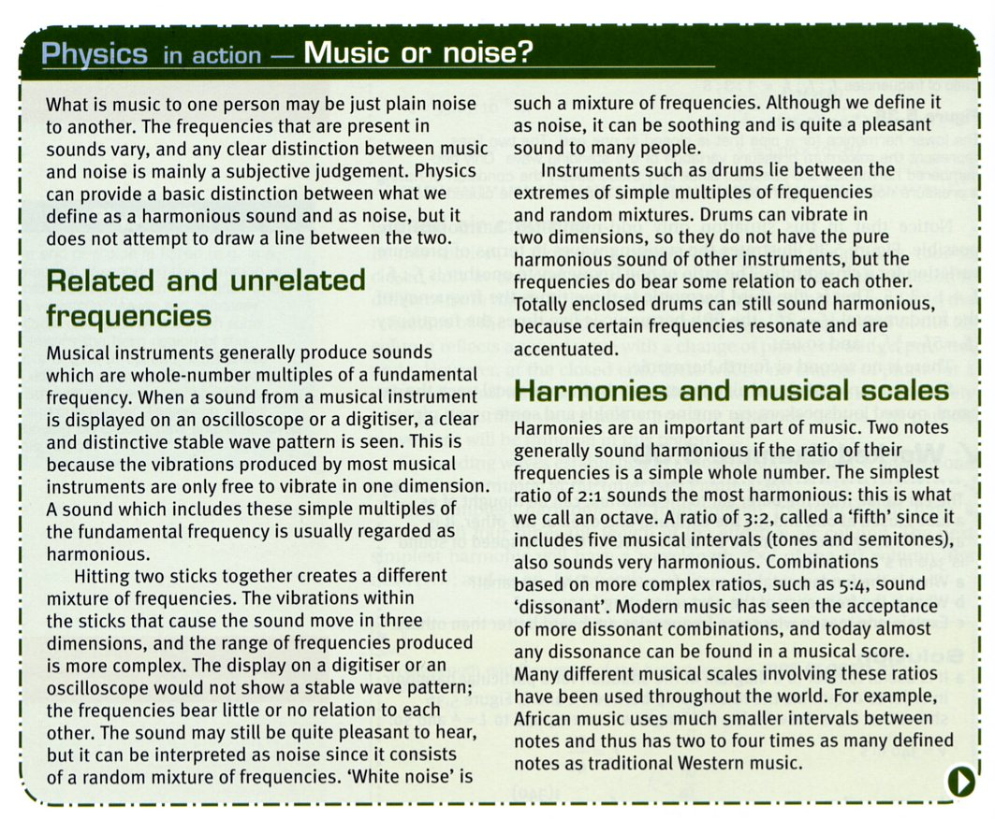
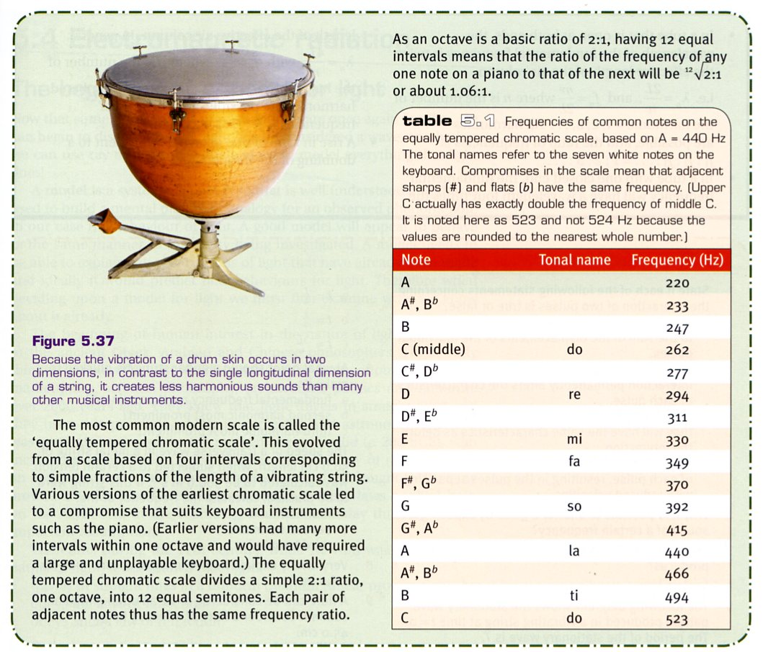

FORCED VIBRATIONS

Objects such as a steel rod, tuning fork or a glass can be made to vibrate by striking them.
i.e. A single force is applied for a short time.

These objects will vibrate at their natural frequency (which depends on their physical dimensions and the material of which they are made.

However, if they are made to vibrate by an application of a periodic driving force (i.e. one applied with a regular frequency) with the same frequency as that of the driving force, this is called forced vibration.

Example

A tuning fork that is struck and held in the hand is very difficult to hear unless it is placed close to the ear.

If it is struck and then placed in contact with a table, it is heard very clearly.

The table is forced to vibrate at the same frequency as the tuning fork. A louder sound is produced because a much larger mass of air in contact with the table is made to vibrate for a shorter period of time.

In musical instruments such as violins and guitars, the wooden frame and the enclosed air columns are forced to vibrate with the same frequency as the strings, thereby increasing the sound intensity.

RESONANCE

When the frequency of the periodic driving force coincides with the natural frequency of the body being forced to vibrate, a large amplitude of vibration is developed.

This phenomenon is called resonance.

Examples

1. A child’s swing. Small pushes given when the swing is about to move back from its
maximum displacement will greatly increase the amplitude of the swing.

2. Stretched strings or air columns have a natural frequency of vibration. Sound waves of the same frequency produced by a vibrating source will cause them to resonate.

3. Parts on a car will vibrate or rattle at particular speeds. The vibrations from the tyres on the
road match the natural frequency of the parts and cause them to vibrate significantly.

4. Dipping a finger in wine and rubbing it gently around the top of a wine glass will cause it to
“ring”. The ridges of the fingerprint cause small vibrations that match exactly the natural
frequency of the air column inside the glass so it resonates.

BEATS

Beats refer to the unusual waxing and waning of sound that is produced when two sounds of similar amplitude but slightly differing frequencies occur at the same time.

i.e. The sound rises and falls in a regular pattern.

Beats are another example of interference between sound waves. The two waves superimpose and produce a single wave whose amplitude varies with time.

The resultant single wave is generated by the algebraic sum of the displacements of the individual waves.

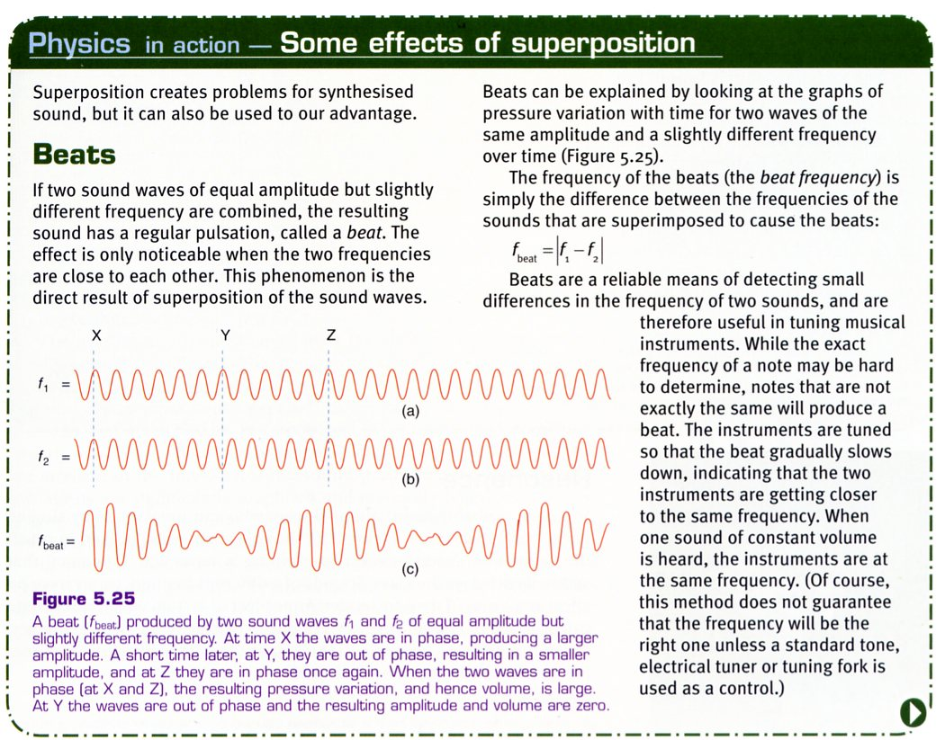

The frequency at which beats are produced is given by:

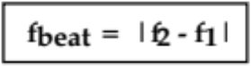

where f_{beat} = the beat frequency of the resultant wave (Hz)
f₁, f₂ = the frequency of the two waves generated at the same
time (Hz)

Example

When a piano note and a tuning fork of frequency 360 Hz are sounded together, 6.5 beats per second are heard. One prong of the tuning fork is loaded with a small piece of wax and the number of beats heard per second is increased. What is the frequency of the piano note?

Putting wax on the fork will slow down the tines so its frequency is lowered.

Since this increases the beat frequency, then the piano note must be higher than the
fork.

∴ f_{beat} = f_{piano} - f_{fork}
=> f_{piano} = 6.5 + 360
= 366.5 Hz

∴ The piano note is 366.5 Hz.

